XFS, GFS and ZFS File System Comparison

Jake Orben
TCNJ Student
5 Weidel Drive
Pennington, NJ
(609)558-7828
orbenjc@gmail.com

Abstract
This is a document reviewing the merits of three file systems. The first is XFS file system, a system included in the current Linux kernel. The next is Google File System, a proprietary file system used with clusters of machines. The final file system is ZFS, a file system designed by Sun Microsystems (now owned by Oracle), ZFS is known for its redundancy and ability to deal with lager storage capacities.
Categories and Subject Descriptors
This paper will include topics on performance, security and reliability in the field of file systems.
General Terms
Performance, security and reliability
Keywords
XFS, GFS, Google File System, ZFS, fragmentation, RAID, RAID-Z, zpool, file system, Linux, Kernel, shadow, shadow drive, ARC

Introduction
File systems are the means by which an operating system stores and retrieves data from a device with read/write capabilities. Without a file system, data would simply be written to a device without any order, this would not only make reading the data all but impossible, it could also lead to loss of data owing to data being overwritten. There are currently countless file systems, however, the three being discussed today are XFS, Google File System and ZFS. Each has its own merits and shortcomings, though each deal with a different field of use, XFS for example is used for a common computer, whereas the Google File System is used on large clusters of machines. As such each of these file systems will deal with a different segment of the computer science world and will be reviewed in its given context.

XFS
XFS is a file system implemented on machines using a flavor of a Linux operating system. It is implemented to work well with the common user, as opposed to being designed for the use of large clusters of machines or in an enterprise environment [8].

2.1 Origins
Silicon Graphics, (a manufacturer of high-performance computer solutions, defunct as of 2009) began development of XFS began in 1993 and was introduced in 1994 as a file system. It was then put into implementation in the Silicon Graphics IRIX 5.3 operating system, a system officially retired in December of 2013 with the last stable release being in August of 2006. The file system was officially released under the GNU General Public License as of 2000, meaning that it was open source and could be ported and molded by any user. It was quickly ported into Linux by the year 2001. This officially meant that any developer could simple take the port and includes XFS in their kernel build of a given distribution of Linux. It is important to note that XFS was not included in a public Kernel until the year 2002 in Linux kernel version 2.4. As a result, prior to 2002 and developer wishing to use XFS had to create their own kernel modification. Once put into the public Linux Kernel, XFS was still scarcely used, owing to some instability issues [9].

2.2 General Information
The XFS file system is 64-bit that supports journaling. The system is based on the B+ tree, which is optimized for multiple read/write operations. The B+ tree differs from the standard binary tree in that each node can have many children as opposed to only two, leading to the aformentioned read/write performance [8].
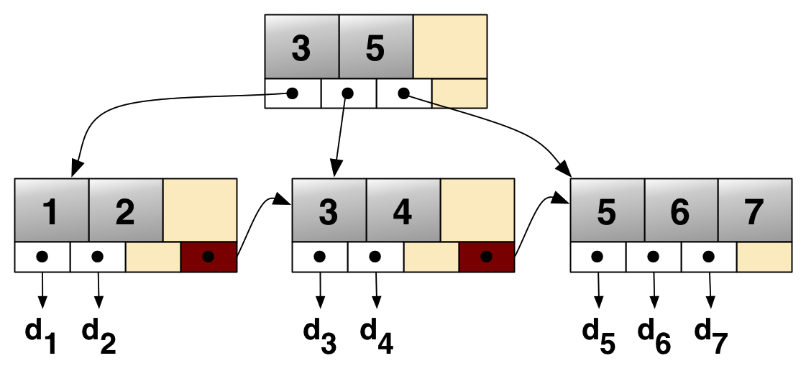[10]

2.3 File Size Info
The maximim file size if 8 exbibytes (EiB) and the max volume size is 16 EiB, however, if implamented in a 32-bit operating system, the max file as well as volume size is limited to 16 tebibytes (TiB) as a result of the lack of addressing space in a 32-bit system. Furthermore, the block sizes on the disk can range from 512 bytes and 64 KB [10].

2.4 Journaling
Journaling is a system by which the integrity of a file system is maintained. Journaling does so by tracking all changes made to the system if a journal file (a cyclical buffer file techinally), then applies those changes to the main file system, this ability allows for more rapid recovery of files as well as a reduction in corrupted files during a system failure [5].

2.5 Allocation groups
XFS is internally partitioned into allocation groups, which are equally sized, similar to block sizes in memory. Any file can be in more that one allocation group, however, each group keeps track of their own inodes or index node [8].

2.6 Extent use
Extents are used to allocate single blocks of memory to allow for more contiguous blocks, leading to a decrease in fragmentation as the more contigous blocks are used, the shorter the seek time on a disk or tape based storage device [4].

2.7 Guaranteed I/O rate
XFS guarantees I/O rate by allowing applications to reserve bandwidth to the filesystem, a unique ability which performs well with high intensity I/O applications such as games or when editing a video [4].

2.8 inodes
An inode is a system used to represent a file system object and includes such data as how many applications are accessing a given file, the metadata of a given file and or the permissions of a given file. The ability to individually manage inodes allows for scalablilty (use in larger or smaller applications without hinderence) as well as parallelism. The reason that parallilism is allowed being that more tan one processes can perform rea/qrite operations at the same time (class and [9]).
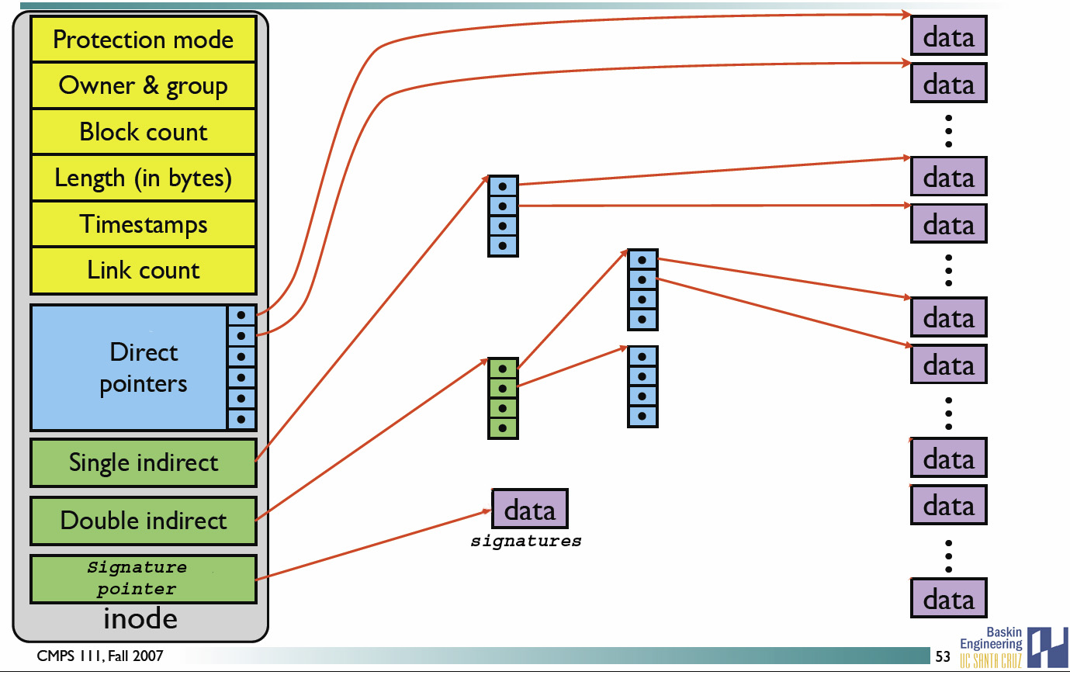
[11]
These are the primary catagories that make up a typical inode.Protection mode dictates if a file is currently protected from writes, the Owner & Group specify which user has control over a given file. Block count states how many blocks on the disk are being used for a given file. The length is the number of conseutive blocks allocated to a file. Timestamps inform of when a file was last edited, in some cases, previous timestamps are kept as well.. Link count is the un,ver of times a file is linked to another or to an application. Direct pointers indicate directly where data is stored, where as single indirect, doublé indirect and even triple indirect are all pointers to other pointers. Finally, the signature pointer indicates a user’s signature.
2.9 Advanced Disk techniques
When using advanced disk techniques such as RAID (a sysem which uses striping across multiple drives to increase performance as well as redundency) the stripe unit can be specified upon creation, allowing for maximum thoughput by synchronizing data allocations, inode allocations as well as the journal with a given stripe [3].

3 Google File System
The Google File System (GFS) is a proprietary system, which is used for clusters of machines to allow reliable access. This file system is used primarily, as far as the public knows, for communication with Google’s search engine. The issue this file system was created to resolve was the massive amount of data that needed to be stored as well as accessed countless times per second [11].

3.1 chunk sizes
All files are turned into chunks of 64 megabytes, similar to sectors in any other file system. After allocated files are generally appended to or read, such as in a search query [12].

3.2 working standards
This system is designed to work with Google’s clusters, which use non-enterprise grade materials, to keep down costs. This however, comes at a cost, for instance, a common computer does not have ECC in the RAM, meaning that errors can occur and system crashes are more possible (personal knowledge and [2]).

3.3 System Mechanics
GFS clusters consist of multiple machines and are divided to two types, a Master node, which controls a large number of Chunkservers. The Chunkservers are used to store the chunks of 64 megabytes previously mentioned. Each chunk is assigned a unique label by the master node when it is created. Furthermore, a map is maintained with the logical mappings of all files. For security purposes, these chunks are written across the network to a minimum of three other clusters, allowing for a high level of redundancy, ensuring that there is rarely a loss of data. It should be noted that the machines being copied to are not necessarily at the same facility, as if one facility loses power, an entire chunk of data could be lost [2].
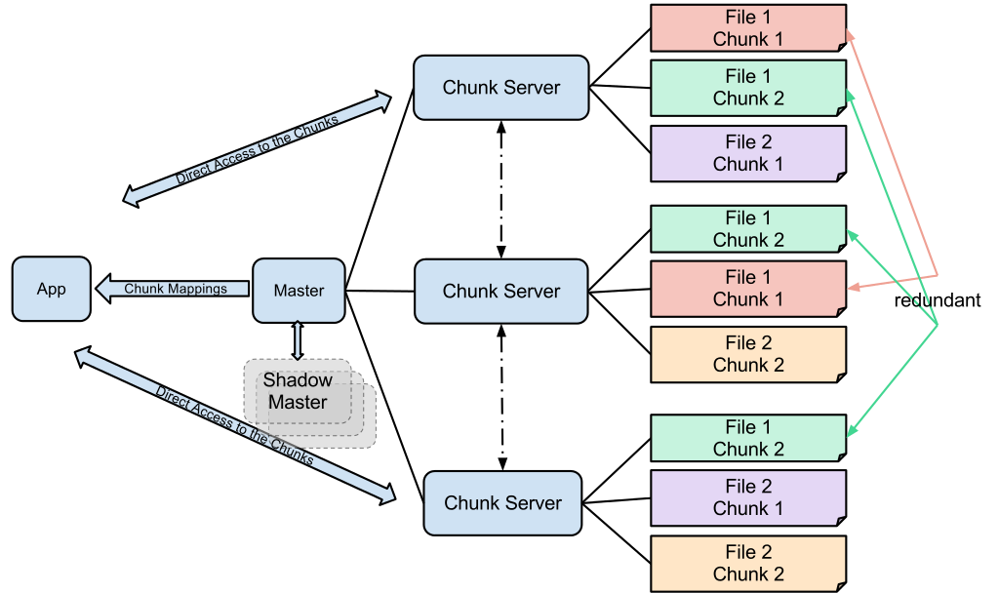
[11]
It should be noted that the Shadow master is simply a backup of the master, often times backups are considered shadows.

3.4 Metadata Storage
The Master node not only stores the mapping table of the chunk servers, it also stores metadata associated with a given chunk. Metadata includes but is not limited to: time created, date modified, current location, if it is being executed, read/write/execute privileges and file name [2].

3.5 Write privileges for a file
Changes to a given chunk or file are allocated by the Master node, which will give a process a discrete amount of time to make the necessary changes, after the time expires, the application will need to ask again for write privileges in order to make another change. After changes are made, the parallel copies of the chunk are updated [2].

4 ZFS
ZFS is a file system as well as a volume manager developed by the then Sun Microsystems (Sun Microsystems was later bought out by Oracle in 2010). ZFS has a high level of protection against failure as ell as the ability to deal with large storage capacities as well as quick compression rates for files. ZFS was originally open-source software licensed under the Common Development and Distribution License however it is now a registed trademark of the Oracle Corporation [13].

4.1 General information
ZFS was first introduced in 2005 in OpenSolaris and uses a hash table in place of the more common B tree or B+ tree. The max file size is 16 EiB and the max volume size is 256 zebibytes (ZiB), which is approximately 256,000 EiB, making it one of the most flexible file systems when dealing with large volume sizes [13].

4.2 Storage Pools
Unlike most systems, ZFS does not use a volume manager; instead, it uses something called a zpool. A zpool is a collective of drives viewed as a single logical drive these zpools can then be used in the RAID-Z system by partitioning the logical drives or by joining with another zpool. There is also another aspect of the zpool, in that a new device can be added and the stripe width will automatically expand to include these new devices [7].
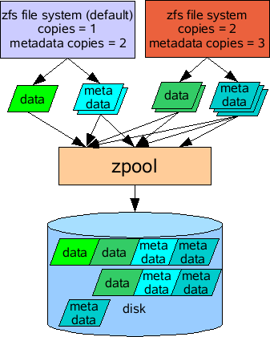
[15]

4.3 Caching
ZFS uses a cache to speed up data access time, like many other file systems; however, it can distinguish between an SSD and HDD, allowing for multiple levels of cache. The highest level being CPU, followed by the CPU cache (this can have multiple levels, the current generation of Intel chips has L4 cache for graphics processing). Next comes RAM, all constantly accessed data will reside in a given amount of RAM, the next most recently accessed data will be stored on SSD and the least used data will reside of HDDs. It is also theoretically possible to have the system distinguish between an HDD spinning at 5400 RPM vsersus one spinning at 10,000 RPM, allowing for more efficient caching. All of this is done using the ARC algorithm an algorithm for page replacement with better performance than Least Recently Used and developed by IBM. The ARC algorithm uses two lists to store cache data, the first list, T1 is used for recent entries, the second list, T2 is used for entries referenced multiple times. Beyond these two lists, are ghost lists B1 and B2, which store metadata of recent items to help predict which items need to be in the T1 or T2 cache for predicted activities [7].
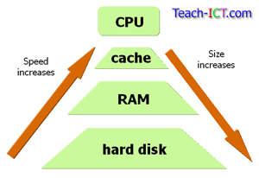[13]
This chart shows the relationship between the fastest form of storage versus the slowest in hierarchy form.
4.4 Possible causes of data loss
One of ZFS’ main focuses is on data security, ensuring against the loss of data. Several things can cause loss of data, such as disk corruption, where data is no longer integrally stable, spikes in current (although a good business will have a power protection system to avoid such issues), issues with disk firmware (no code is perfect, if firmware misdirects data it can be lost), misdirected reads and or writes (occurs when a disk accesses the wrong block of data, does not occur on Solid State Disk SSD technology), as well as a variety of other possible issues. Many of these errors can still occur in advanced techniques such as RAID, making the need for ZFS quite large, especially in an enterprise environment [13].

4.5 Data Safety
The safety of data in ZFS comes from using a checksum throughout the entire file system. A checksum is a series of characters that describes a given set of data, if the checksum of data does not match, there is an error. The checksums are stored in a pointer as opposed to the block itself, preventing issues with a corrupted block of data. This is a recursive process, as the next block pointer is the next checksum. If checksums do not match, the issue is dealt with by taking data from a confirmed disk running in parallel or using parity bit, such as in RAID 1 and RAID 5 respectively [7].

4.6 RAID and ZFS
When using ZFS, it is most efficient to use the Just a Bunch Of Disks (JBOD), which takes a given number of disks and turns them into one logical volume. The use of regular RAID is also fine, however, using a RAID card (an internal add-on PCI card for most PCs, though it can also be built into a motherboard) this is due to the fact that the card will interfere with the data restoration process, by striping the incoming backup data. The reason that the use of RAID is not recommended is that ZFS needs perfectly redundant copies and when using a system such as RAID 0 even if two copies exist, a single disk failure will take out the entire system and ZFS will not be able to recover anything due to the striping across disks [7].

4.7 RAID-Z
Software RAID is supported by ZFS using a system called RAID-Z, a system similar to RAID 5 in nature with internal integrity backups if a single disk fails. RAID-Z1 allows for up to one disk to fail, where as RAID-Z2 allows up to two disks to fail RAID-Z3 is used to ease the load on systems which have had large disk failures, disks which contain over terabytes of data can take weeks to fully repair due to the massive amount of data stored. ZFS also offers a system similar to RAID 1, however, instead of having two disks in parallel it allows for as many disks as the user requests to be used, allowing for incredible backup security [1].
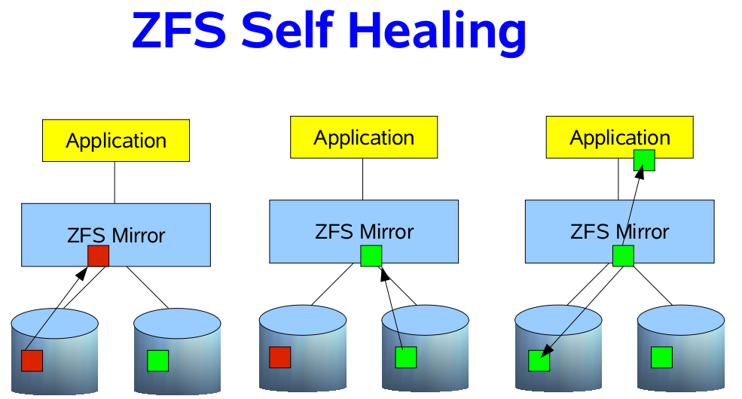[14]
This is an example of how ZFS performs self healing when using a RAID-Z1 configuration.

5 Conclusion
Each of these file systems has their own merit, although they are used for entirely different applications. XFS is terrific for a standard computer user going about their every day tasks such as editing a word document or editing a picture. In contrast, GFS has a stronger level of redundancy as well as providing high read speeds, allowing for many queries to take place almost simultaneously. Finally, ZFS has unparalled redundancy as well as ability to deal with volumes of incredible size, making it ideal for services such as data storage, much the same as Amazon’s Web Services provide with their cloud storage solutions.
6 References
- Cifuentes, J., and J. Cano. "Analysis and Implementation of Anti-Forensics Techniques on ZFS." IEEE. N.p., n.d. Web. 27 Apr. 2014. <http://ezproxy.tcnj.edu:2229/xpl/articleDetails.jsp?tp=&arnumber=6222582&queryText%3Dzfs>. Used for some review of redundancy on the ZFS.
- Google. Google, n.d. Web. 27 Apr. 2014. <http://static.googleusercontent.com/media/research.google.com/en/us/archive/gfs-sosp2003.pdf>. Used for information regarding the Google File System.
- mythtv. N.p., n.d. Web. 27 Apr. 2014. <http://www.mythtv.org/wiki/Optimizing_Performance#XFS-Specific_Tips>. Talks about disk management in XFS.
- Nakamura, T., and N. Komoda. "Pre-allocation Size Adjusting Methods Depending on Growing File Size." IEEE. N.p., n.d. Web. 27 Apr. 2014. <http://ezproxy.tcnj.edu:2229/xpl/articleDetails.jsp?tp=&arnumber=4685843&queryText%3Dxfs>. Used for information about XFS, primarily on how data is stored.
- princeton.edu. N.p., n.d. Web. 27 Apr. 2014. <http://www.princeton.edu/~achaney/tmve/wiki100k/docs/Journaling_file_system.html>. Used for information on journaling.
- Pugh, C., et al. "Utilizing zfs for the storage of acquired data." IEEE. N.p., n.d. Web. 27 Apr. 2014. <http://ezproxy.tcnj.edu:2229/xpl/articleDetails.jsp?tp=&arnumber=5226462&queryText%3Dzfs>. Used to fill in some gaps of ZFS.
- Rodeh, O., and A. Teperman. "zFS - a scalable distributed file system using object disks." IEEE. N.p., n.d. Web. 27 Apr. 2014. <http://ezproxy.tcnj.edu:2229/xpl/articleDetails.jsp?tp=&arnumber=1194858&queryText%3Dzfs>. Used to go over the scalability and other information about ZFS.
- Wang, R.Y.; Anderson, T.E., "xFS: a wide area mass storage file system," Workstation Operating Systems, 1993. Proceedings., Fourth Workshop on , vol., no., pp.71,78, 14-15 Oct 1993
doi: 10.1109/WWOS.1993.348169
- Whitemice Consulting. N.p., n.d. Web. 27 Apr. 2014. <http://www.whitemiceconsulting.com/2010/09/xfs-inodes.html>. Reviews inodes in XFS.
- Wikipedia. Wikipedia, n.d. Web. 27 Apr. 2014. <http://en.wikipedia.org/wiki/XFS>. Used as a starting point for XFS.
- Wikipedia. Wikipedia, n.d. Web. 27 Apr. 2014. <http://en.wikipedia.org/wiki/Zfs>. Used for general overview of ZFS.
- Wikipedia.org. Wikipedia.org, n.d. Web. 27 Apr. 2014. <http://en.wikipedia.org/wiki/Google_file_system>. Used for general overview of GFS.
- http://www.teach-ict.com/gcse_computing/ocr/212_computing_hardware/cpu/miniweb/images/cache.jpg
- www.i.iinfo.cz/images/188/zfs-self-healing-orig.png
- www.1.bp.blogspot.com/-fHvGVj5tM_s/TkuhUGvf29I/AAAAAAAACtk/nqUTa4P7sGo/s1600/zfs_zpool.png

